EXPERIMENT-5
Name : M.N.Dharaan
Roll no : 240701117

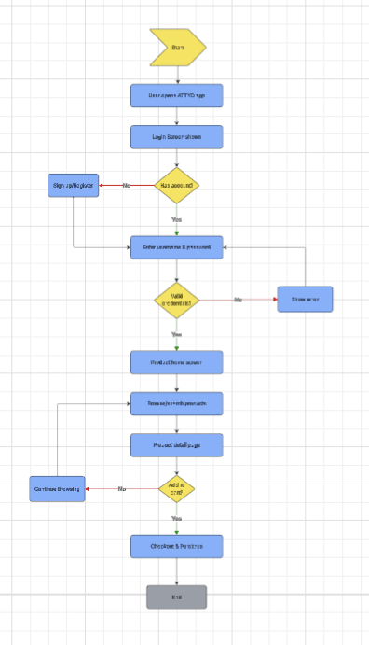
Flowchart in Lucidchart

Wireframe of the following flowchart
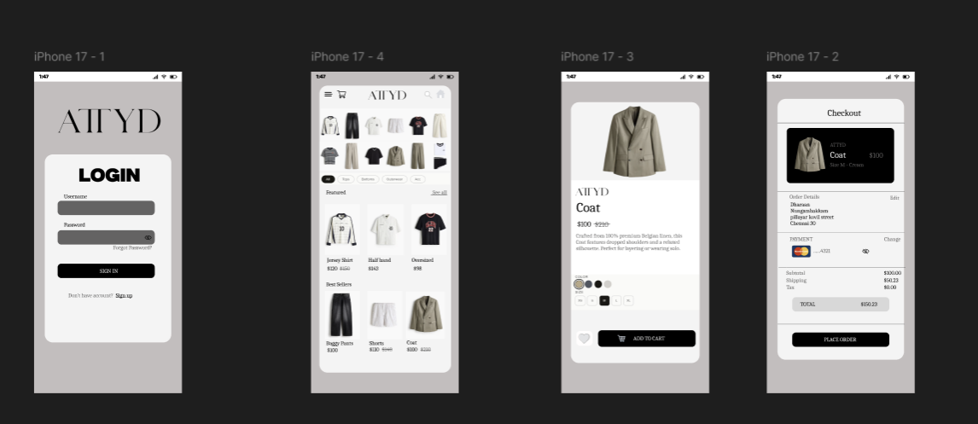

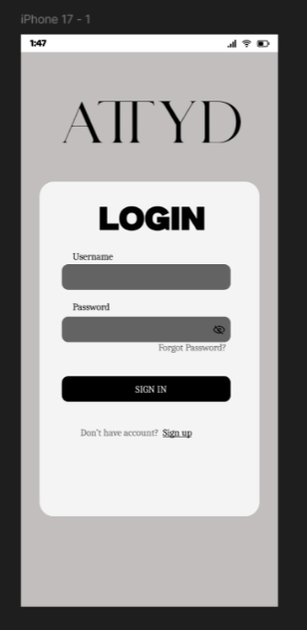

Frame 1 – Login / Welcome Page

This screen is the starting page of the application. It allows users to log in using their registered account details.

Main Elements
- Email Field – Users can enter their email address.
- Password Field – Used to enter account password securely.
- Login Button – Allows users to access their account.
- Sign Up Option – New users can create an account if they do not have one.
Purpose
This page helps users enter the application safely and quickly.

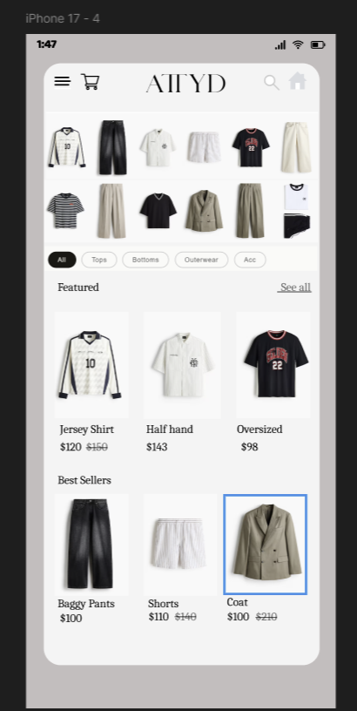

Frame 2 – Home Page
This screen is the main page where users can browse products and explore available categories.

Main Elements
- Search Bar – Helps users find products easily.
- Category Section – Displays different product categories.
- Featured Products – Shows trending or recommended items.
- Navigation Menu – Helps users move to other sections like cart or profile.

Purpose
This page allows users to explore products and begin shopping.

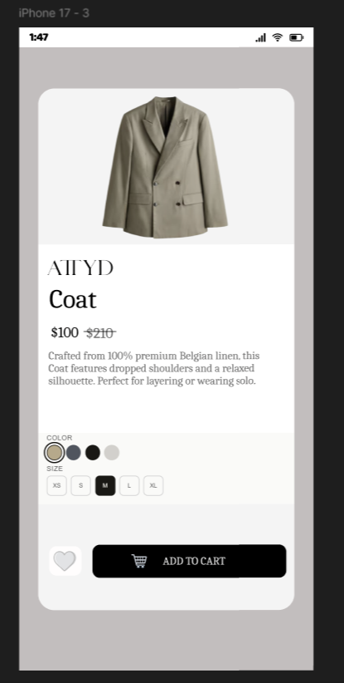

Frame 3 – Product Details Page
This screen provides complete information about a selected product.

Main Elements
- Product Image – Displays the selected item clearly.
- Product Name – Shows the product title.
- Price – Displays the cost of the product.
- Description – Gives details about size, material, or features.
- Add to Cart Button – Lets users add the item to their cart.

Purpose
This page helps users understand the product before purchasing.

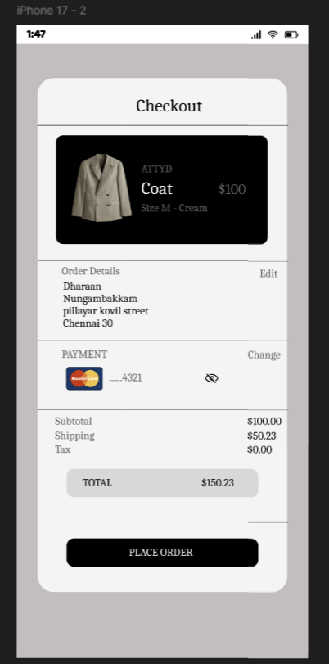

Frame 4 – Cart / Checkout Page
This screen shows the items selected by the user and allows payment.

Main Elements
- Selected Products List – Displays products added to the cart.
- Quantity Controls – Users can increase or decrease quantity.
- Total Amount – Shows final payable amount.
- Payment Options – Users can choose their preferred payment method.
- Checkout Button – Used to place the order successfully.

Purpose
This page helps users review their order and complete the purchase.

